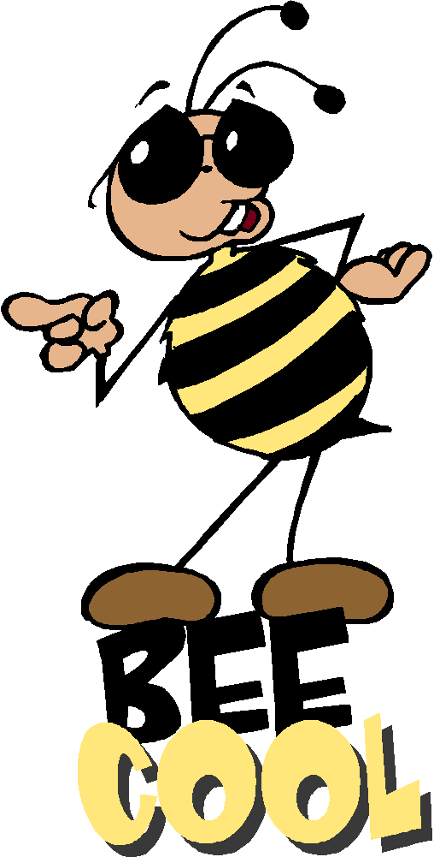
Sort 12 Spelling Words
Short u (CVC) and long u (CVCe and CVVC)

bump prune bruise bloom build skunk cute juice moon built trust flute suit tooth grunt crude cruise spoon plus mule smooth

Spelling Test Friday on ten of your weekly spelling words, remember to study every night.

Sort 12 Spelling Words
Short u (CVC) and long u (CVCe and CVVC)

bump prune bruise bloom build skunk cute juice moon built trust flute suit tooth grunt crude cruise spoon plus mule smooth

Spelling Test Friday on ten of your weekly spelling words, remember to study every night.

Sort 12 Spelling Words
Short u (CVC) and long u (CVCe and CVVC)

bump prune bruise bloom build skunk cute juice moon built trust flute suit tooth grunt crude cruise spoon plus mule smooth

Spelling Test Friday on ten of your weekly spelling words, remember to study every night.

